User Guide
Coordi Hub
Room Booking & Coordination Requests System
Khorfakkan Hospital
https://kfn-three.vercel.app
Prepared by: Coordination Office
29 September 2026

Introduction
Coordi Hub is an internal digital system for Khorfakkan Hospital that lets every staff member book meeting rooms, submit and track coordination requests with the Coordination Office, create checklists, upload shared files, and follow up on statistics — plus a floating AI assistant that helps you complete these tasks through direct conversation.
The system supports both Arabic and English; you can switch the language and light/dark mode at any time from the icons at the top-right of any page.
System URL: https://kfn-three.vercel.app
Each staff member logs in with the email and password provided by the system administrator.
This guide is split into two parts: (1) core pages available to every staff member, and (2) pages available only to Admin accounts for managing the system and its settings.
Note: a few screenshots in this guide — specifically the admin accounts table and the system email settings — have had real data (names, emails, phone numbers, and login credentials) hidden to protect staff privacy and account security. This has no effect on the usage instructions themselves.

Part One: Core Pages for All Staff

Home – Rooms & Bookings
The first page after login. Shows every room available for booking with its location and capacity, plus a monthly calendar of scheduled bookings.
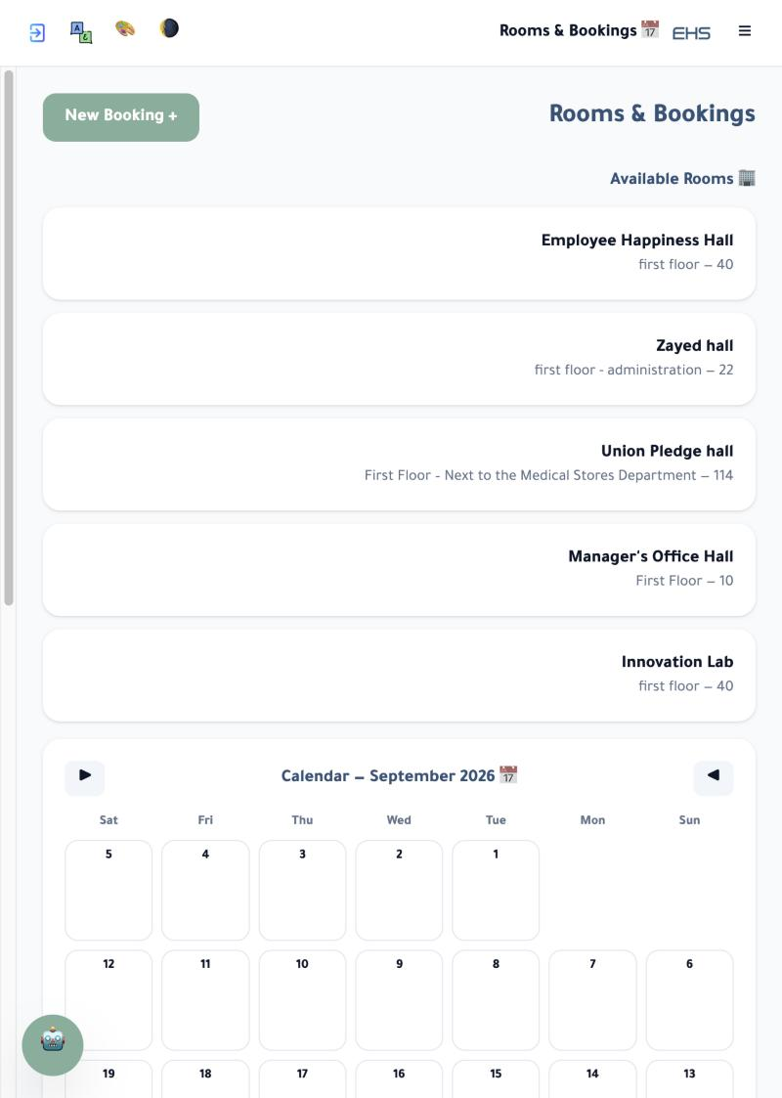
Field / Element | Description
New Booking + | Opens the new room booking form (next page).
Room card | Room name, location (floor/department), and maximum capacity.
Monthly calendar | Use the arrows to browse months; each day shows its bookings.

New Booking Form
Opened from the "New Booking +" button on the Rooms & Bookings page.
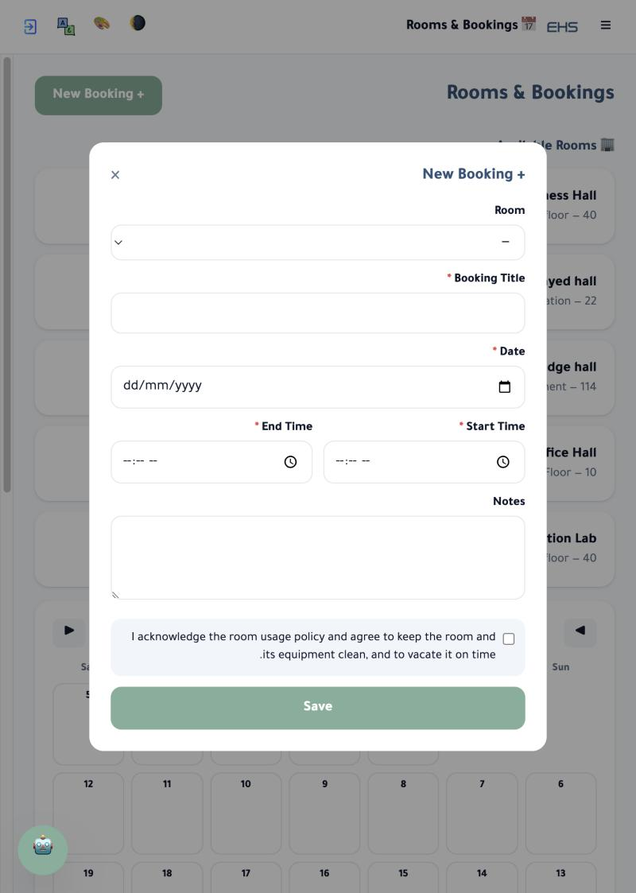
Field / Element | Description
Room | Select the room to book.
Booking Title * | Required — a short title describing the purpose of the booking.
Date * | Booking date (required).
Start Time / End Time * | Booking start and end time (required).
Notes | Optional field for any extra details.
Usage policy acknowledgement | Required checkbox confirming the room and its equipment will be kept clean and vacated on time; wording is set per room in Program Settings.

Coordination Requests
A page for submitting and tracking internal coordination requests (design, circulars, official letters, certificates of appreciation, newsletters, etc.).
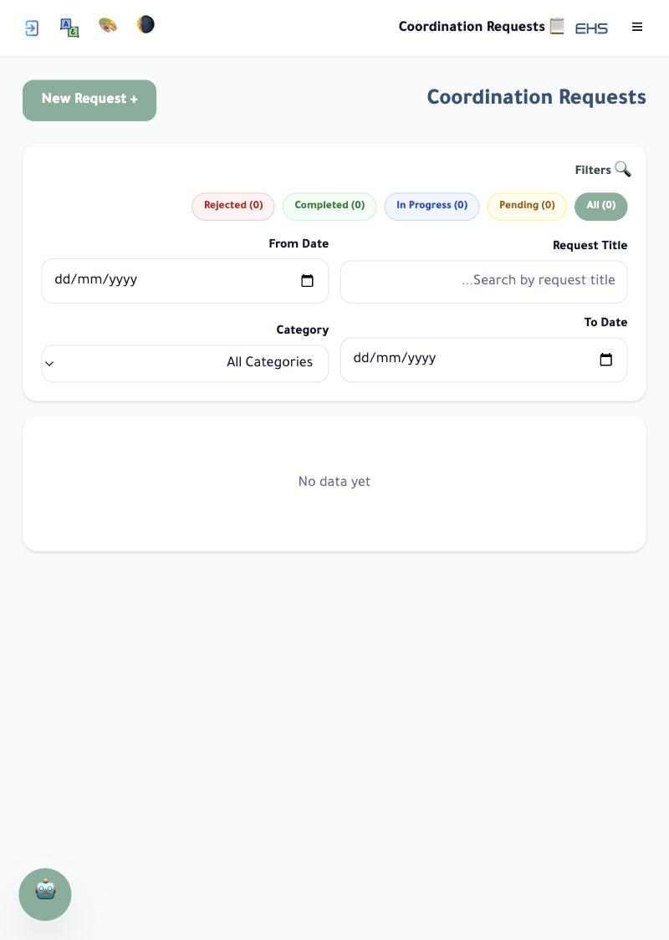
Field / Element | Description
New Request + | Opens the new request form (next page).
Status filters | All / Pending / In Progress / Completed / Rejected — each with a live count.
Search filters | From Date, To Date, Request Title, and Category.

New Coordination Request Form
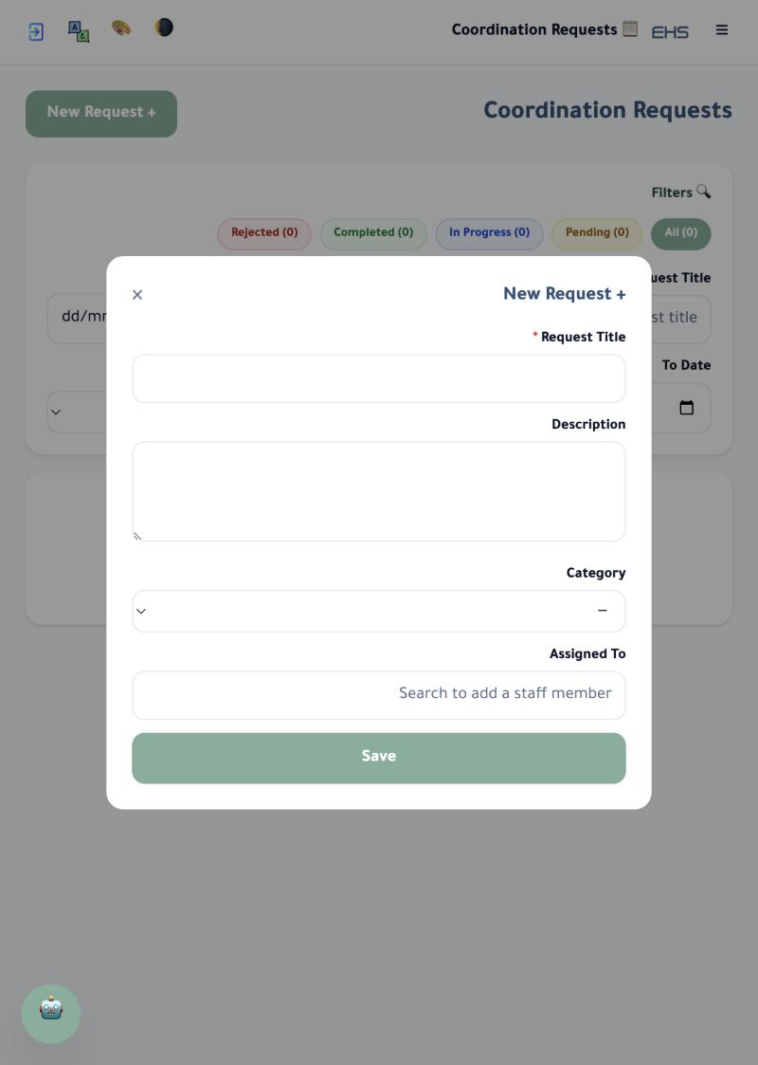
Field / Element | Description
Request Title * | Required field.
Description | Optional details of the request.
Category | Select the request type from the pre-configured categories (managed in Program Settings).
Assigned To | Search and assign the request to a specific staff member to action it.

Checklists
Create checklists for recurring tasks (e.g. routine inspection rounds).
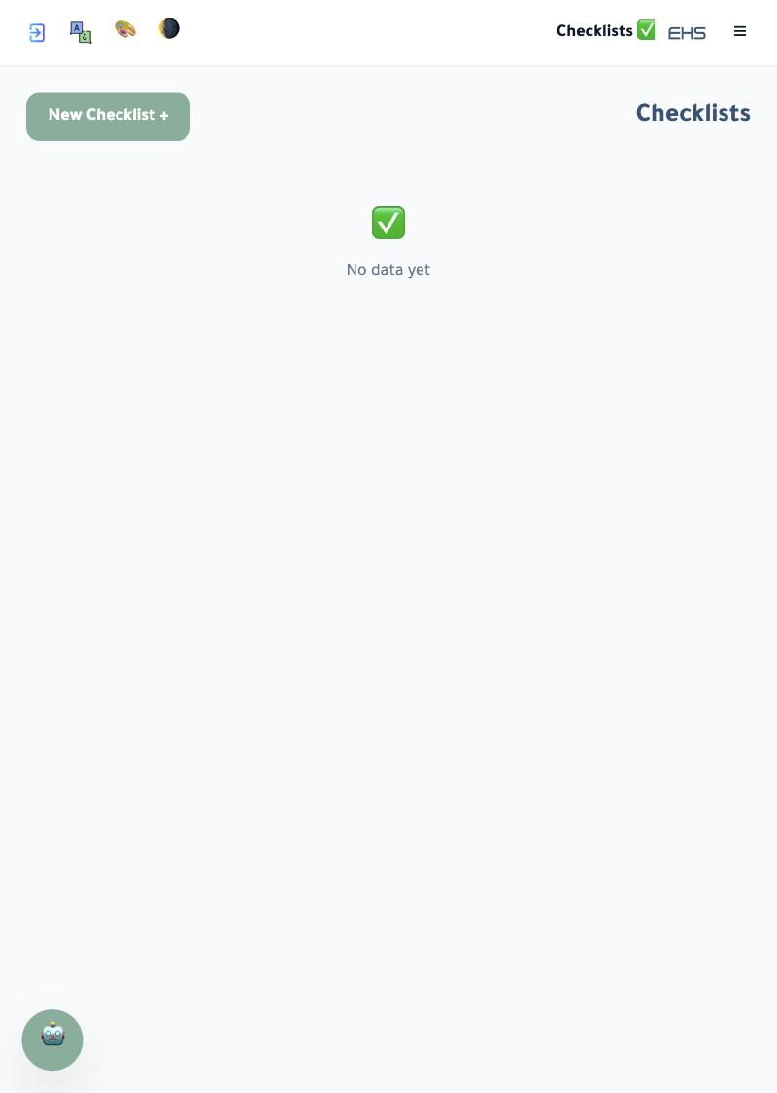
Field / Element | Description
New Checklist + | Opens the new checklist form (next page).

New Checklist Form
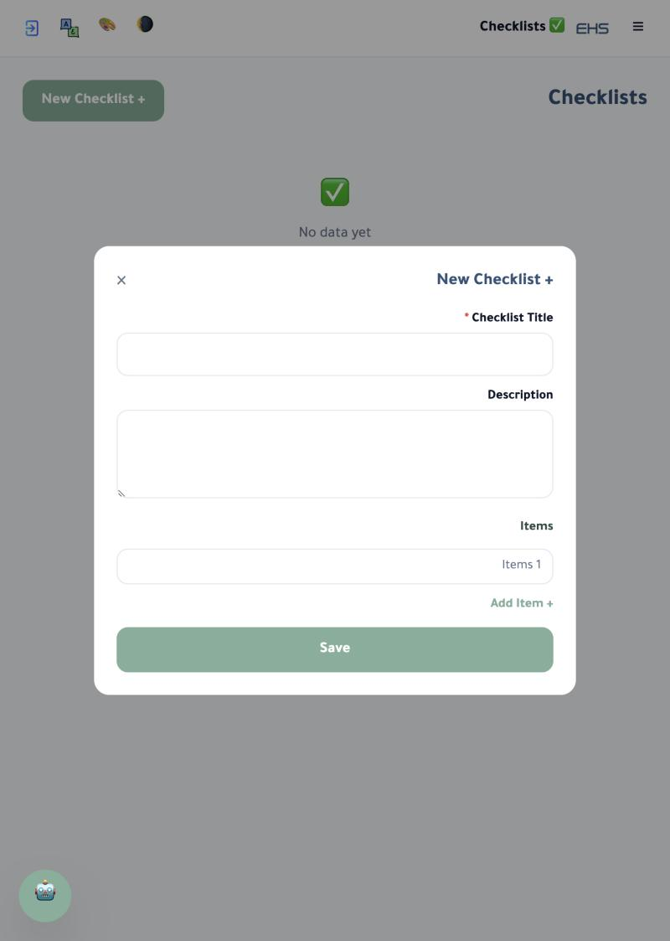
Field / Element | Description
Checklist Title * | Required field.
Description | Optional field.
Items | Add checklist items one by one using "Add Item +".

Files & Documents
A shared space for uploading and storing files and documents.
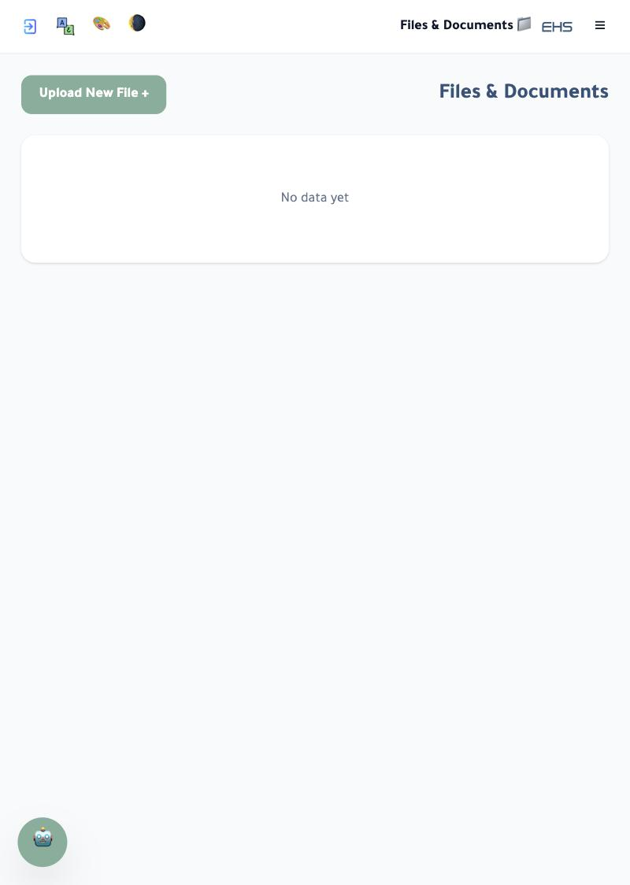
Field / Element | Description
Upload New File + | Opens your device's file picker directly; after choosing a file, a dialog asks for the file's Arabic and English name before saving.

Statistics & Reports
A full overview of booking and request activity.
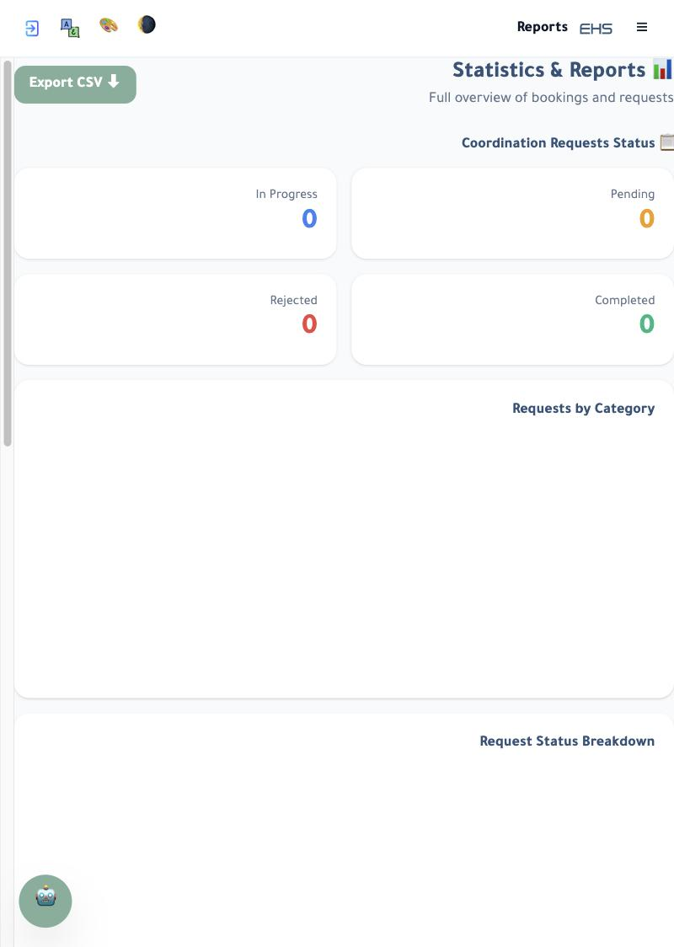
Field / Element | Description
Export CSV | Download the report data as a CSV/Excel file.
Request status cards | Counts of requests: In Progress, Pending, Rejected, Completed.
Requests by Category | Chart showing requests distributed across categories.
Request Status Breakdown | Chart of requests by status.

Navigation Menu
Opened via the ☰ icon at the top-right of any page; it is how you move between all pages of the system.
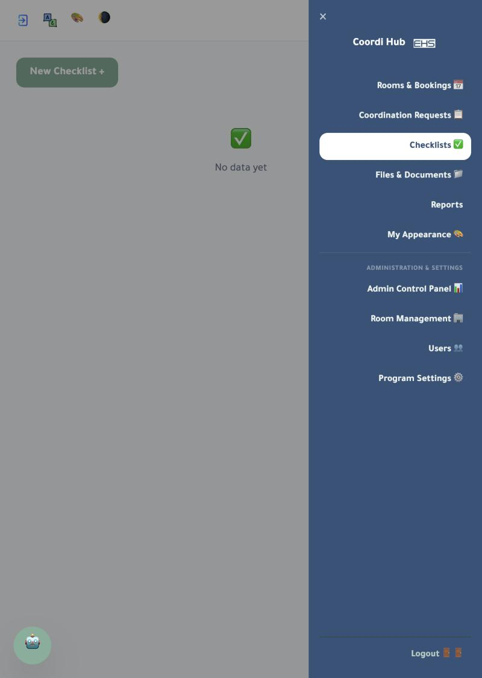
Field / Element | Description
Rooms & Bookings, Coordination Requests, Checklists, Files & Documents, Reports, My Appearance | Links available to every staff member.
Admin Control Panel, Room Management, Users, Program Settings | "Administration & Settings" section — visible to admin accounts only.
Logout | Always at the bottom of the menu.

My Appearance
A personal color customization visible only to you, without affecting other users.
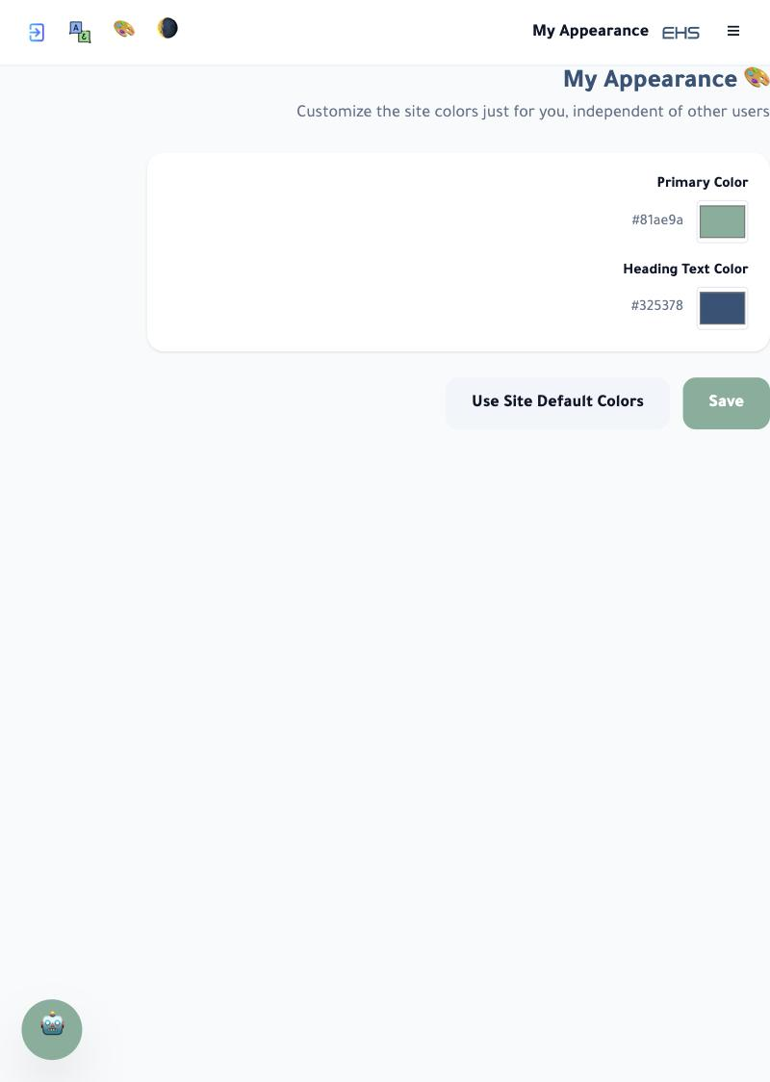
Field / Element | Description
Primary Color | Hex code + color picker.
Heading Text Color | Hex code + color picker.
Use Site Default Colors | Clears your personal customization and restores the site-wide colors.

Part Two: Admin-Only Pages

Admin Control Panel
The main system-management page — visible only to "Admin" accounts.
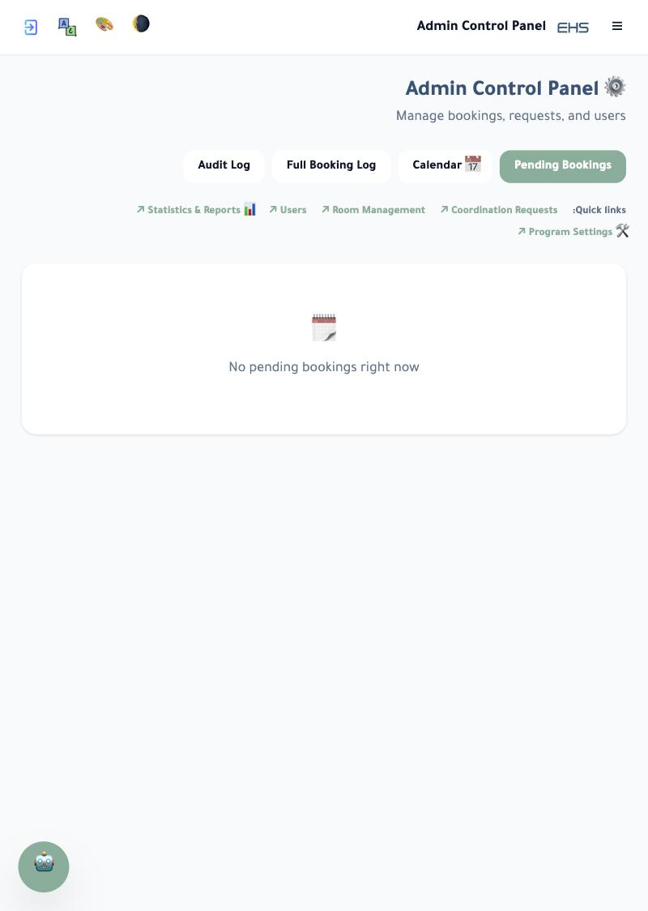
Field / Element | Description
Pending Bookings | Default tab — bookings awaiting the room approver's confirmation.
Full Booking Log | Every booking across all rooms, in every status.
Calendar | A calendar view of all bookings.
Audit Log | A log of important actions taken across the system.
Quick links | Statistics & Reports, Users, Room Management, Coordination Requests, Program Settings.

Room Management
Add or delete rooms and set the approvers responsible for confirming their bookings.
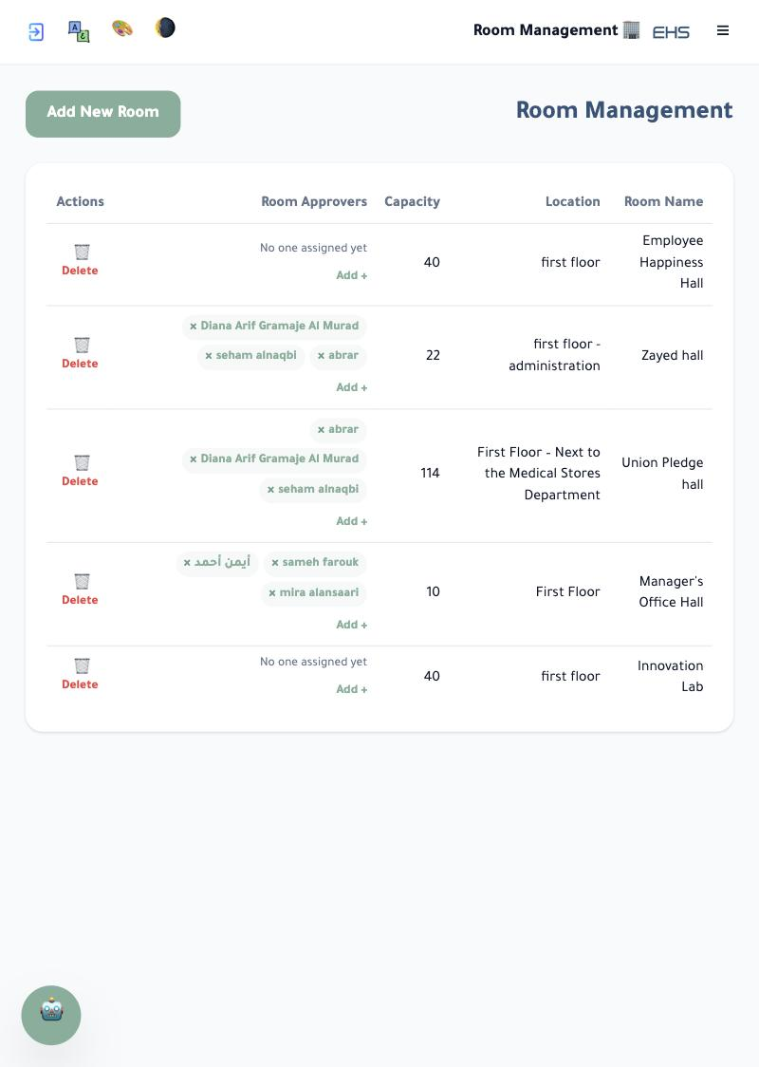
Field / Element | Description
Add New Room | Button at the top of the page.
Room Name / Location / Capacity | The room's basic details shown on the bookings page.
Room Approvers | Add one or more staff ("Add +"); if no approver is set, bookings are confirmed automatically without review.
Delete | Permanently deletes the room.

Users
Manage user accounts, split into two tabs.
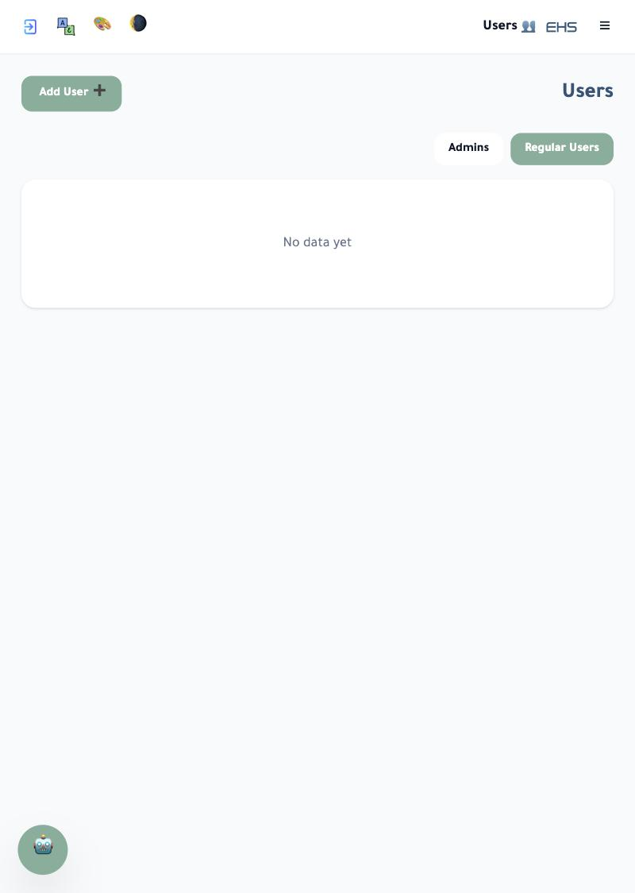
Field / Element | Description
Add User + | Opens the new-account form (next page).
Regular Users | Staff accounts.
Admins | Full administrative accounts — see next page.

Users – Admins Tab
Shows a table of admin accounts: Name, Email, Phone Number, Department, and Role. Real names, emails and phone numbers have been hidden in this guide to protect staff privacy.
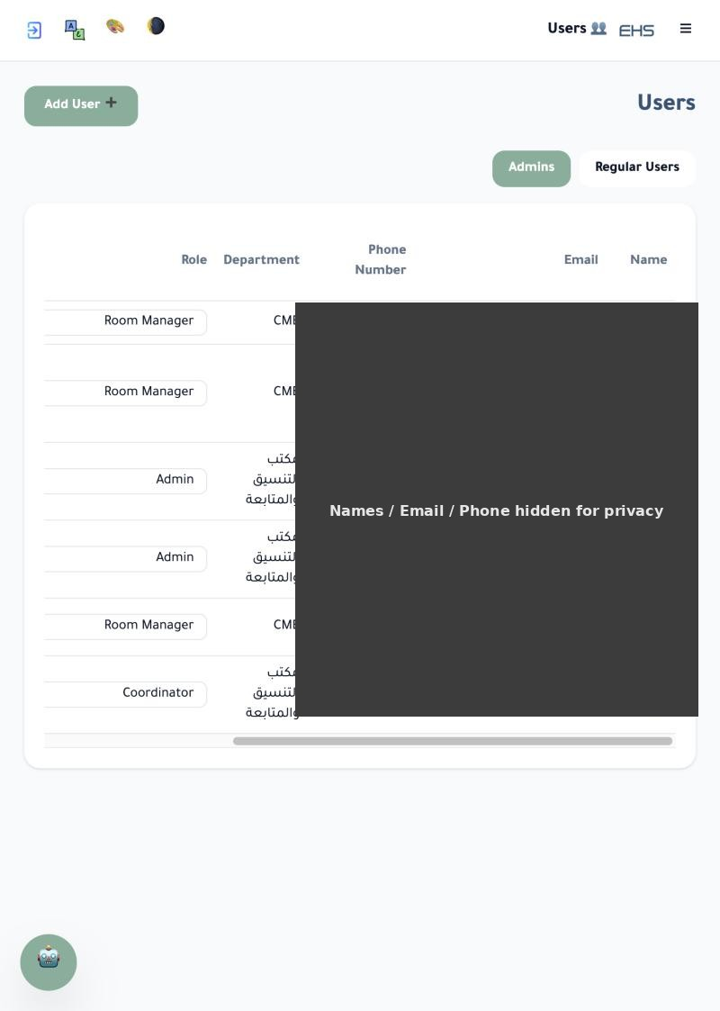
Field / Element | Description
Role | e.g. Room Manager, Coordinator, Admin.
Department | The administrative department the account belongs to.

Add User
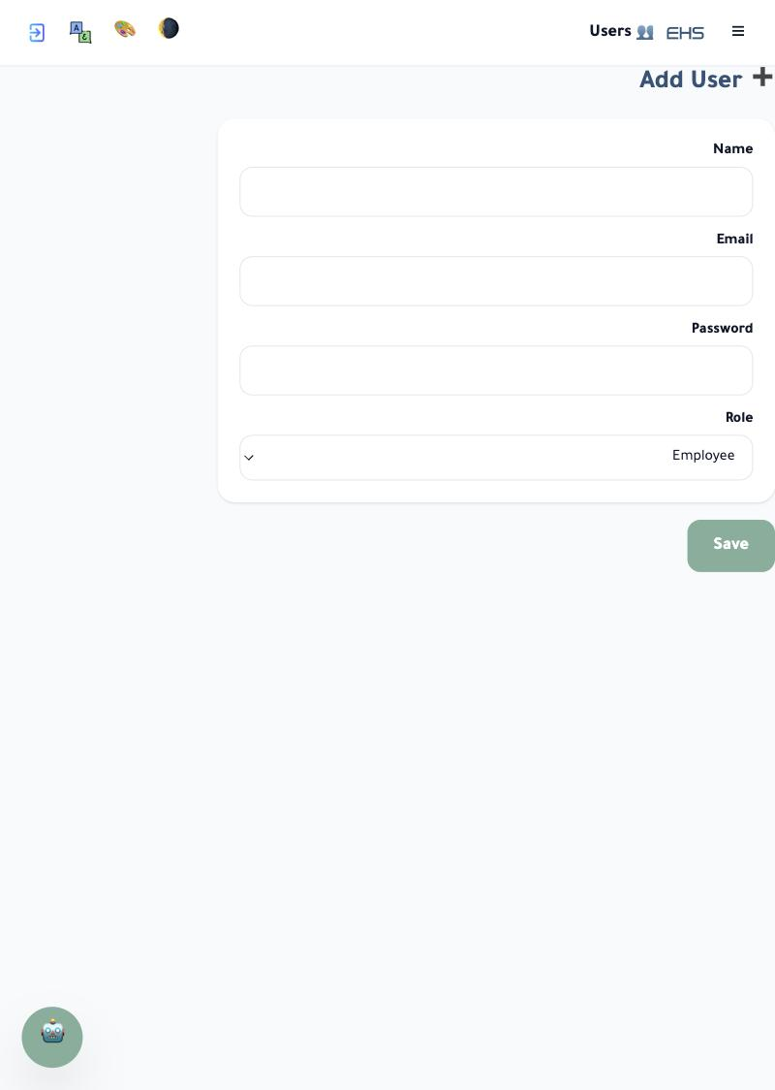
Field / Element | Description
Name | The staff member's name.
Email | Used to log in.
Password | An initial password for the account.
Role | Employee by default, or a higher administrative role as needed.

Program Settings – General (1): Booking Notifications
The "General" tab inside Program Settings — admin only.
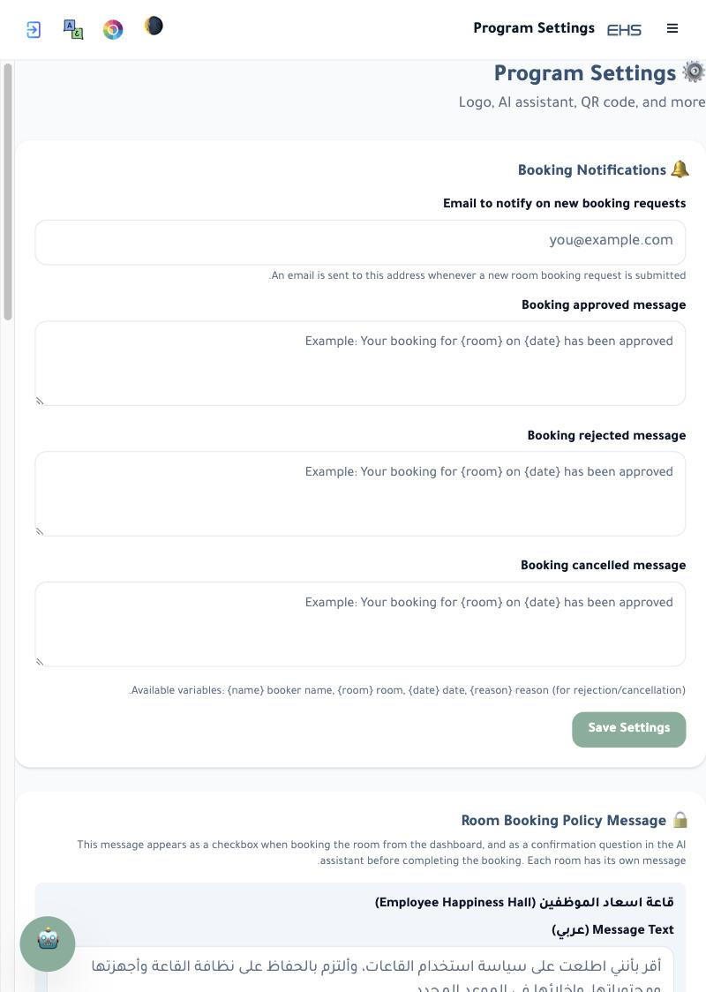
Field / Element | Description
Email to notify on new booking requests | Receives an automatic email whenever a new room booking is submitted.
Booking approved / rejected / cancelled message | Automatic message templates sent to staff; support variables: {name} booker name, {room} room, {date} date, {reason} reason.
Room Booking Policy Message | A per-room acknowledgement text (Arabic/English) shown as a checkbox when booking, and confirmed by the AI assistant too before completing a booking.

Program Settings – General (2): Site Colors & Portal Identity
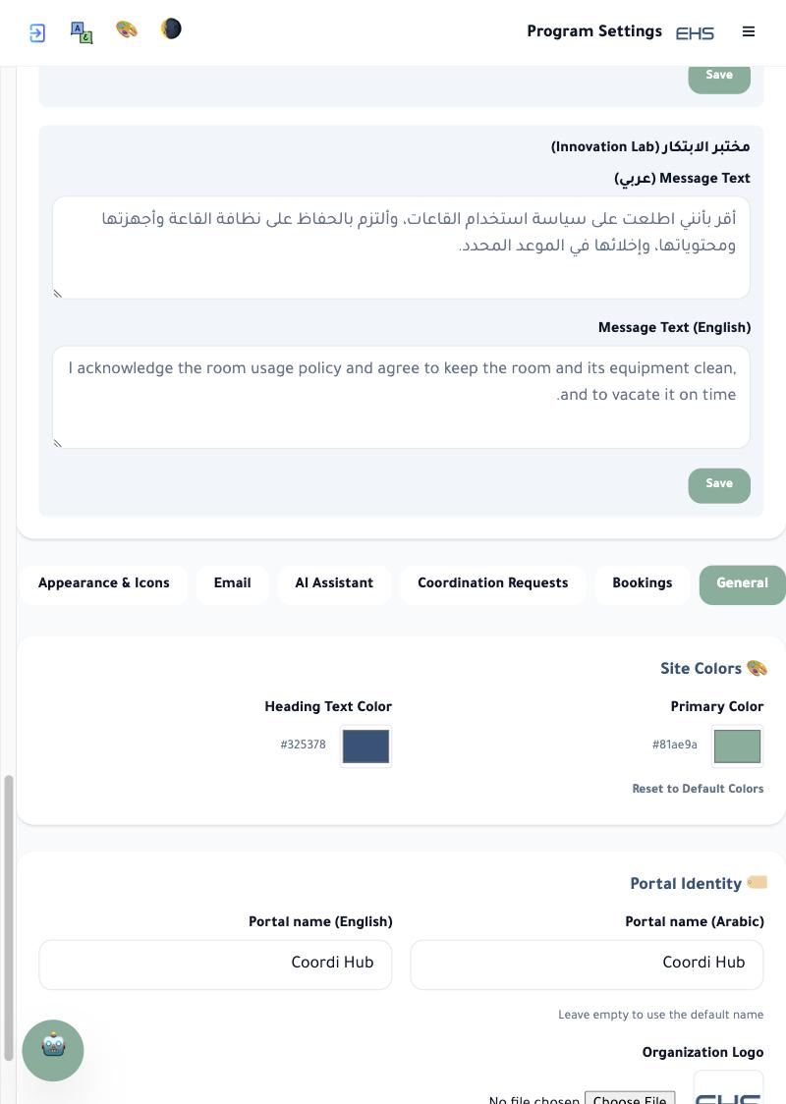
Field / Element | Description
Site Colors | The default primary color and heading color for all users; a Reset to Default Colors button.
Portal Identity | Portal name in Arabic and English, and the organization logo (image upload).

Program Settings – Appearance & Icons
Full control over the icons at the top of every page (Dark Mode, Colors, Language, Logout): their order and shape. Any change here appears instantly for all users with no need to log out and back in.
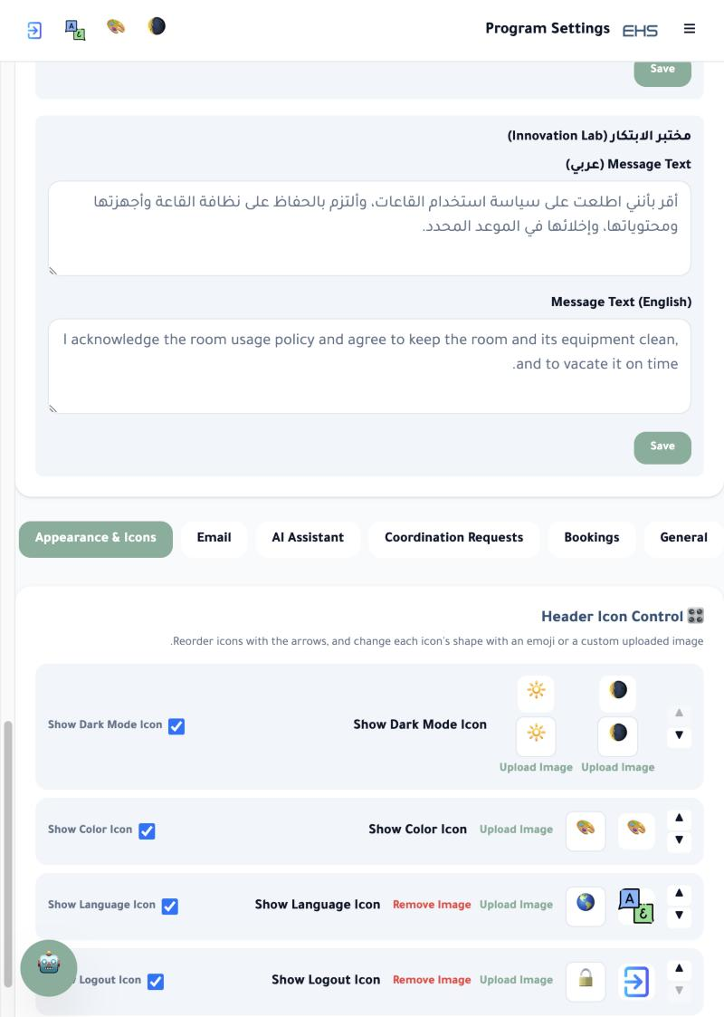
Field / Element | Description
Show-icon checkbox | Hides/shows a specific header icon.
▲ / ▼ | Changes the display order of the icons.
Emoji choice | Two ready-made emoji options per icon to choose between.
Upload Image | Use a custom image instead of the emoji for that icon.
Remove Image | Appears after uploading an image, to restore the icon's default emoji.

Program Settings – Bookings (Colors)
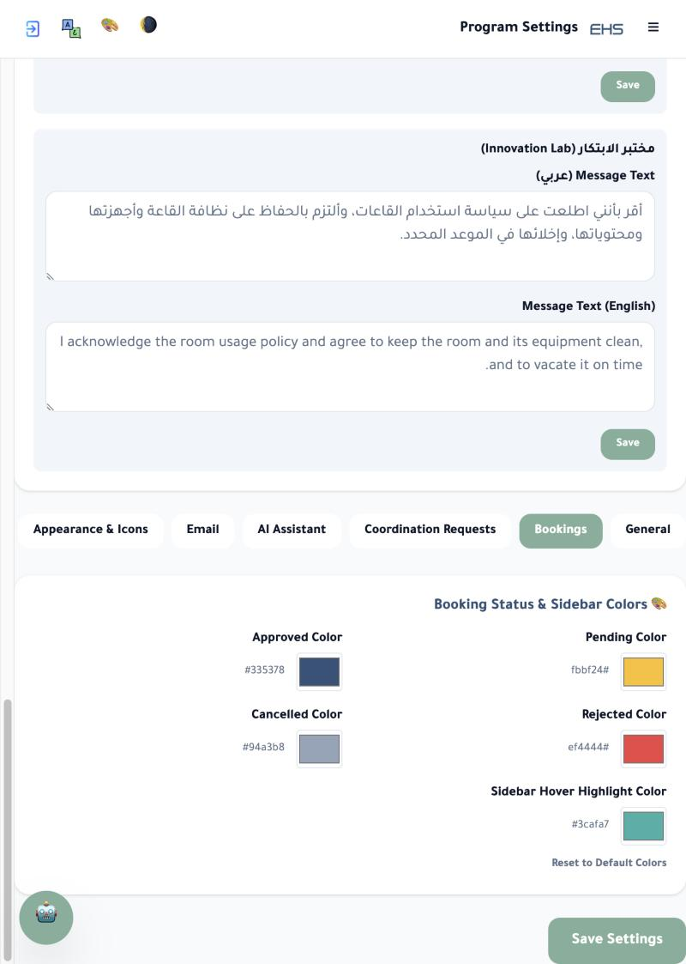
Field / Element | Description
Pending / Rejected / Approved / Cancelled colors | Booking-status colors shown in the calendar and lists.
Sidebar Hover Highlight Color | The highlight color when hovering over sidebar items.
Reset to Default Colors | Restores all the colors above to their original values.

Program Settings – Coordination Requests (Categories)
Manage the coordination-request categories shown in the "New Request" form.
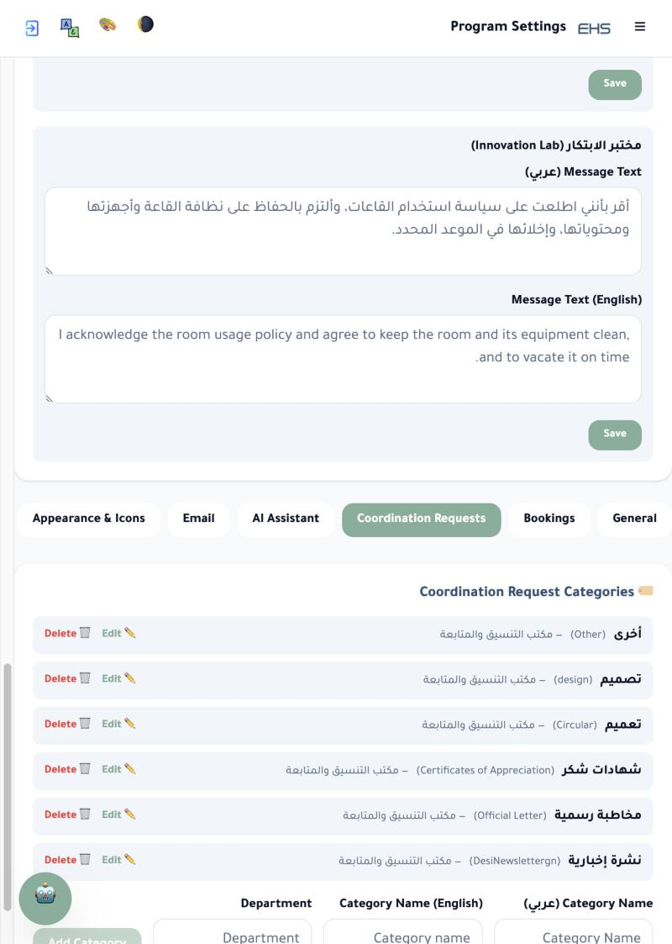
Field / Element | Description
Category Name (Arabic/English) | The name shown to staff when selecting a category.
Department | The administrative department linked to this category.
Edit / Delete | Actions for each existing category, plus a form below the table to add a new one.

Program Settings – Email
Configure the system's outgoing-mail service (via Brevo/SMTP). Actual login credentials have been hidden in this guide for account security.
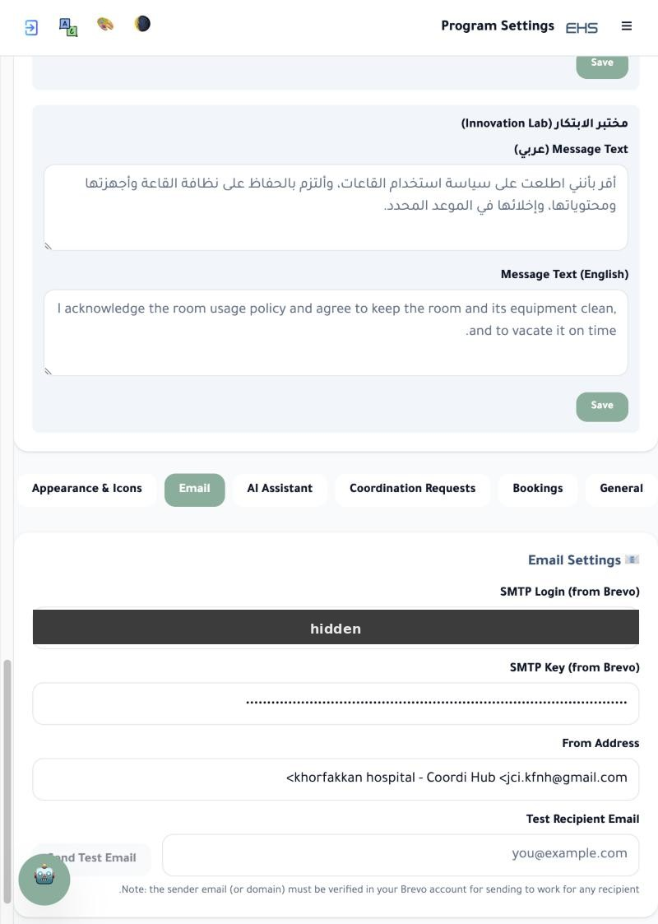
Field / Element | Description
SMTP Login / SMTP Key | Connection credentials for the email-sending service (Brevo).
From Address | The name and email address the recipient sees as the sender.
Test Recipient Email | Send a test email to confirm the settings are working.

Program Settings – AI Assistant
Settings for the floating AI assistant (the small icon at the bottom-left of every page) that helps staff book rooms and ask questions directly inside the system.
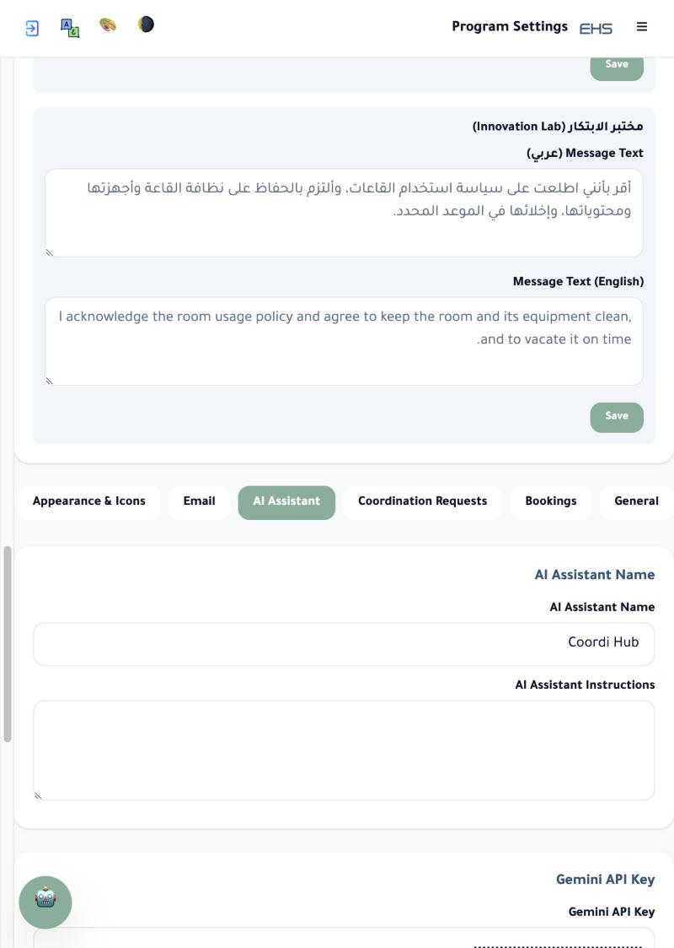
Field / Element | Description
AI Assistant Name | The name shown to staff.
AI Assistant Instructions | The prompt that shapes how the assistant responds.
Gemini API Key | The key connecting the assistant to the AI service (Google Gemini).
Voice Recording Link | An optional link to enable voice input.
Show floating AI assistant | Turns the assistant icon on/off for all users.

Portal QR Code
At the bottom of the AI Assistant tab in Program Settings — a ready QR code that opens the system link directly, handy for staff to scan and open the portal quickly on their phone.
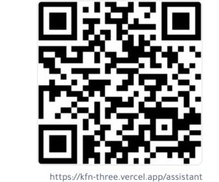

Support & Questions
For any question or technical issue using the system, please contact the Coordination Office.

